SPORTS BRACE
User’s Manual

The Sports Brace is the smartest daily tracker that lets you monitor your steps, calories burned, and your sleeping habits to give you a much deeper understanding of your fitness and well-being. . The SPORTS BRACE is connected devices that will give you simultaneous, multipoint tracking of your daily activities and habits.

The specifications of SPORTS BRACE include:
- Lightweight, incredibly comfortable TPU bangle
- Polycarbonate casing that provides housing to Mainboard that makes it waterproof (IP67)
- Bluetooth version: V4.0 BLE
- Lamp which for notification
- a quantifiable self action-oriented APP that provides real-time activity tracking and reports

The SPORTS BRACE’s functions include:
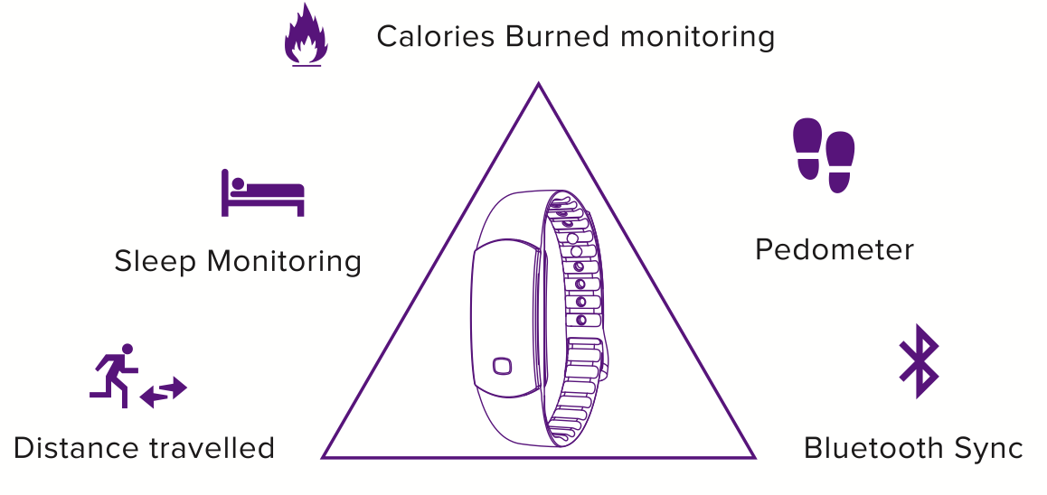
- Reminder notifications, including call reminders, goal completion reminders, alarm clock with vibration
- In the Box:

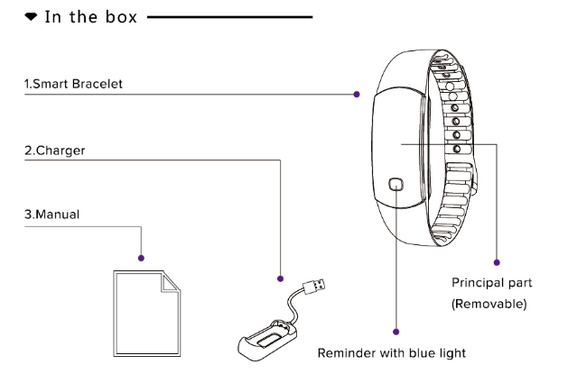

2. How to Assemble THE SPORTS BRACE
Putting the band together is easy.
- Insert the SPORTS BRACE bean in the middle of the band to secure it in place.
- Squeeze the clasp into the holes on the wristband to secure it.
- Make sure the bean faces upwards, like how you would wear a watch.

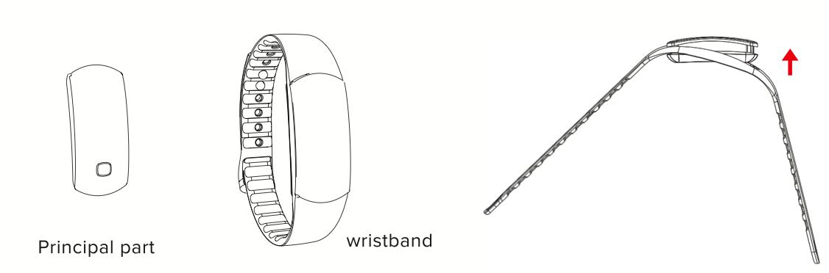
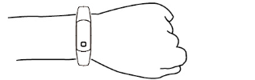

3. Charging THE SPORTS BRACE “BEAN”:
THE SPORTS BRACE comes with a USB charging dongle, which can be plugged into any USB port. Here are instruction on how to charge THE SPORTS BRACE “bean”.
- Detach the bean from the band by popping it out.
- Insert the bean to the USB dongle charger.
- Plug the dongle into a USB port.
- The bean will turn on as it charges.
- You can refer to the status light while the band is charging
  - 0% -90% light lit
  - 90% -99% light flashes
  - 100% light goes out
4. Download the APP :
THE SPORTS BRACE band and the APP are compatible with mobile devices using Android 4.3 OS and has a Bluetooth 4.0 capability. For Apple products, iPhone5/5c/5s/6/6Plus with iOS 7.0 or above systems.
- Go to Google Play for Android or the App store for iPhone or Apple products
- Type “SMART SPORTS BRACE” and download.
- Run the app once the download has completed.
- Select the device you want to pair
- You can now pair THE SPORTS BRACE bracelet with the APP .

5. System Requirements for Mobile Devices:
1 Android devices: Android 4.3 OS and higher, Bluetooth 4.0
2 Apple Devices: iOS 7.0 and above, Bluetooth 4.0

6. Pairing THE SPORTS BRACE with Mobile Device:
Once you have downloaded the APP, run the application on your mobile device and make sure that your Bluetooth is also turned on.
- Open “SMART SPORTS BRACE” on your mobile device.
- Once the interface “Me” comes on, click on the “Lock” icon.
- The APP will search for available devices so you would need to keep the Bluetooth open.
- Double tap the little square on THE SPORTS BRACE when the light starts to flash.
- The band will vibrate once and the indicator light will turn off after it has been paired correctly to your mobile device.
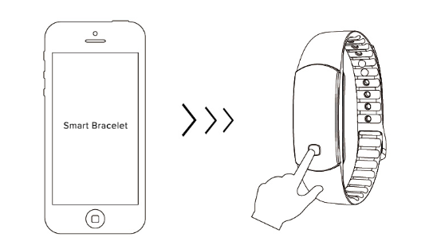

7. Using THE SPORTS BRACE :
After you have locked The SPORTS BRACE with your device, you can now set up your goals by navigating through. Goals can be set to the number of steps taken, calories burned or distance travelled. You can also set up how you could monitor your sleep through this dashboard.

- How to set up your profile
- Once you have downloaded the app, you will be prompted to turn your Bluetooth on. It will then try to search The SPORTS BRACE and pair it with your device.
- After the devices have paired up, tap on “Me” to set up your profile.
- Tap on “My Profile” and fill out the in formation needed, then tap “done” when you’re finished.
- The APP will help you set up your goals based on the information you provide.

- Setting up your Goals
- Under the “Me” dashboard, click on “Goal” and you will be directed to the target steps slider.
- Slide the button to your desired target steps (e.g. 2000 steps) then click on “Done” on the upper right corner to save your preferences.
- The goals you set will show on your Home page.

- Setting up Call reminders
- You can turn call reminders on under the “Me” dashboard.
- Click on the arrow located at the right side of “Call Remind” to change the settings.
- Adjust the number of seconds your band will vibrate for the call reminder and text messages.
- Click “Done” on the upper right corner to save your preferences.
Note: If your phone is equipped with third party assistants or housekeepers, please add The SPORTS BRACE to your white list.

- Setting up Smart Alarm/Sleep Mode
- Click on the arrow located on the right side of “Smart Alarm” under the “Me” dashboard.
- Click on one of the options available and set it to your desired wake up time.
- You can also set up the days of the week that you want the alarm to be applied to.
- Click on “Done” to save your preferences.

- Tracking Goals
The SPORTS BRACE will track your progress automatically and will send you small nudges throughout the day to make sure that you are hitting your goals.

The indicator light will flash Blue when you hit your goals. Vibration series will be as follows:

  - The light on 8 seconds vibrate twice when you achieve 50% of your goal
  - The light on 8 seconds vibrate four times when you achieve 75% of your goal
  - The light on 8 seconds vibrate six times when you achieve 100% of your goal

8. Data Tracking, Call Alerts and Notifications:
THE SPORTS BRACE
On top of its tracking functions, THE SPORTS BRACE also notifies you of incoming calls .Here are a few things that the band will notify you of:
- Wake up alarm
- Low battery status
- Charge Indication/Fully charged Status
- Goal Achievement
- Synchronization
- Call Notification
- Reminders

LED Light Indications
Synchronization: The light flashes 5 times
Call Notification： Lights lit, bracelet vibrate

9 . Bracelet Parameters :
Battery Type: Lithium polymer battery
Battery Capacity: 45MAH
Import Voltage: DC5.0V
Import Current: 45MA (TYP)
Connection: Bluetooth 4.0BLE
Waterproof Rate:IP67
System Requirements:
Android 4.3 or above mobile phone with Bluetooth 4.0
IPhone5/5c/5s/6/6Plus with IOS7.0 or above system

10. Safety Instructions and Reminders:
• Please read these instructions before operating the device.
• Make sure to keep these instructions.
• Heed all warnings
• Follow all instructions
• Do not attempt to open the tracker. Substances contained in this product and/or its battery may damage the environment and/or human health if handled and disposed of improperly.
• Do not tamper with The SPORTS BRACE.
• Do not use abrasive cleaners to clean the band.
• Do not place The SPORTS BRACE in a Dishwasher, Washing Machine or Dryer.
• Do not expose The SPORTS BRACE to extremely high or low temperatures.
• Do not use The SPORTS BRACE in a sauna or steam room.
• Do not leave The SPORTS BRACE in direct sunlight for an extended period of time.
• Do not leave The SPORTS BRACE near open flames.
• Do not dispose of The SPORTS BRACE in a fire. The battery could explode.
• Do not attempt to disassemble The SPORTS BRACE, it does not contain serviceable components.
• Never allow children to play with The SPORTS BRACE. The small components may be a choking hazard.
Built-in Battery Precautions
• Do not attempt to replace your The SPORTS BRACE’s battery. It is built-in and not changeable.
• Charge the battery in accordance with the instructions supplied with this guide.
• Use only the charger that shipped with your product to charge the battery.
• Charge The SPORTS BRACE using a certified computer, powered hub or power supply
• Do not attempt to force open the built-in battery

